Backtests on 21.20.2024

Trade all futures available (without Micro futures). The account size is not $10 million, as we don’t restrict number of positions.

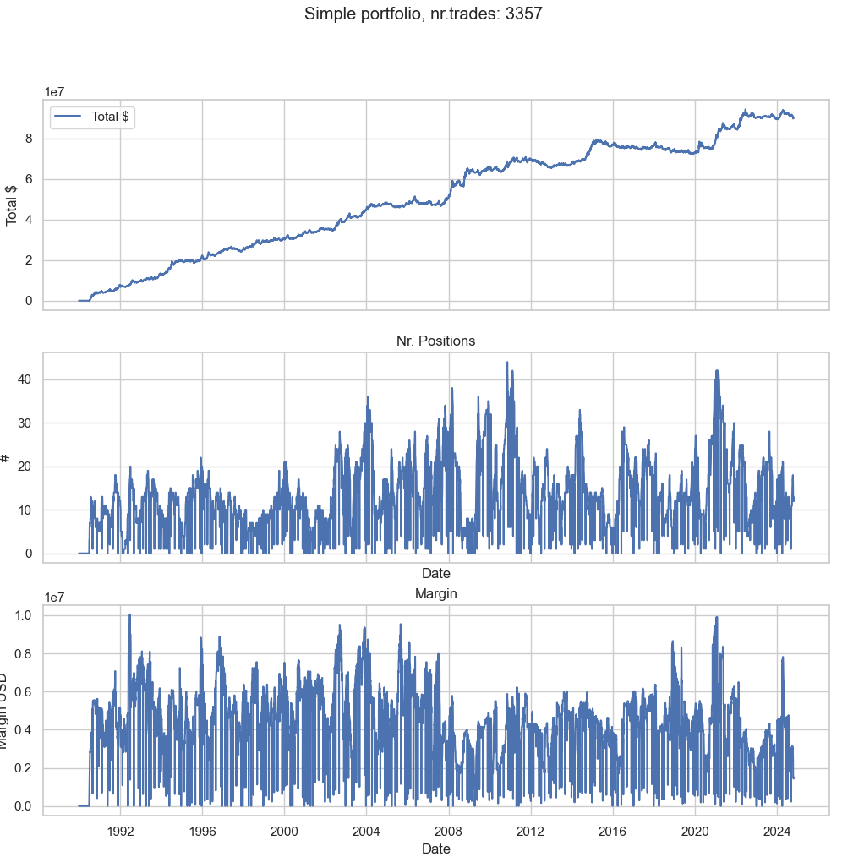

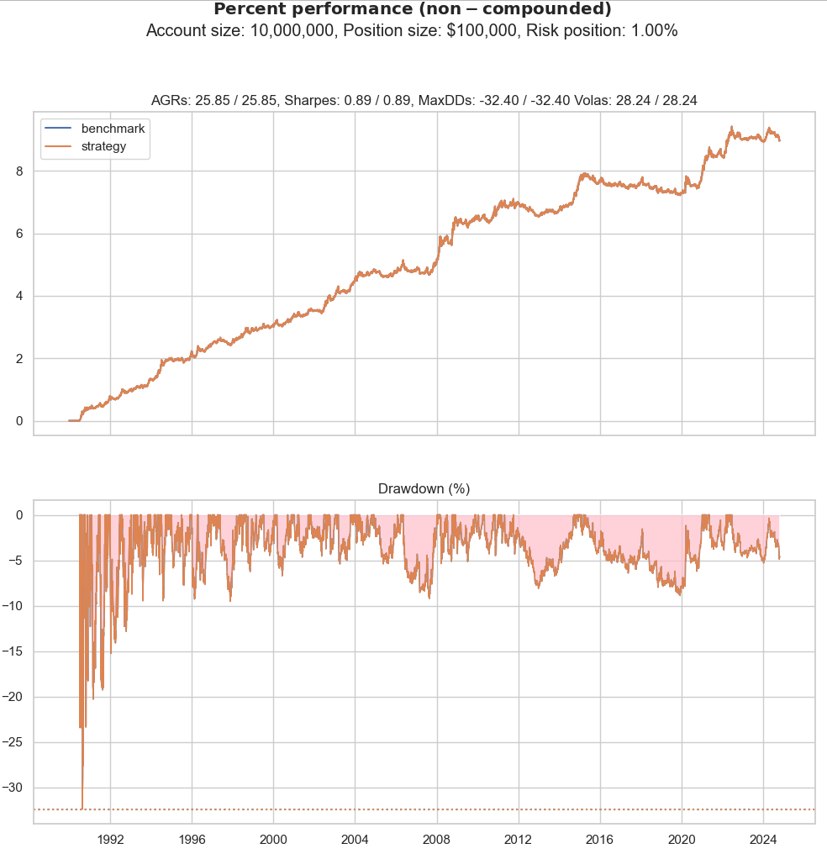

The same as above, but trade only contracts in USD (so that we don’t need to trade in different times)

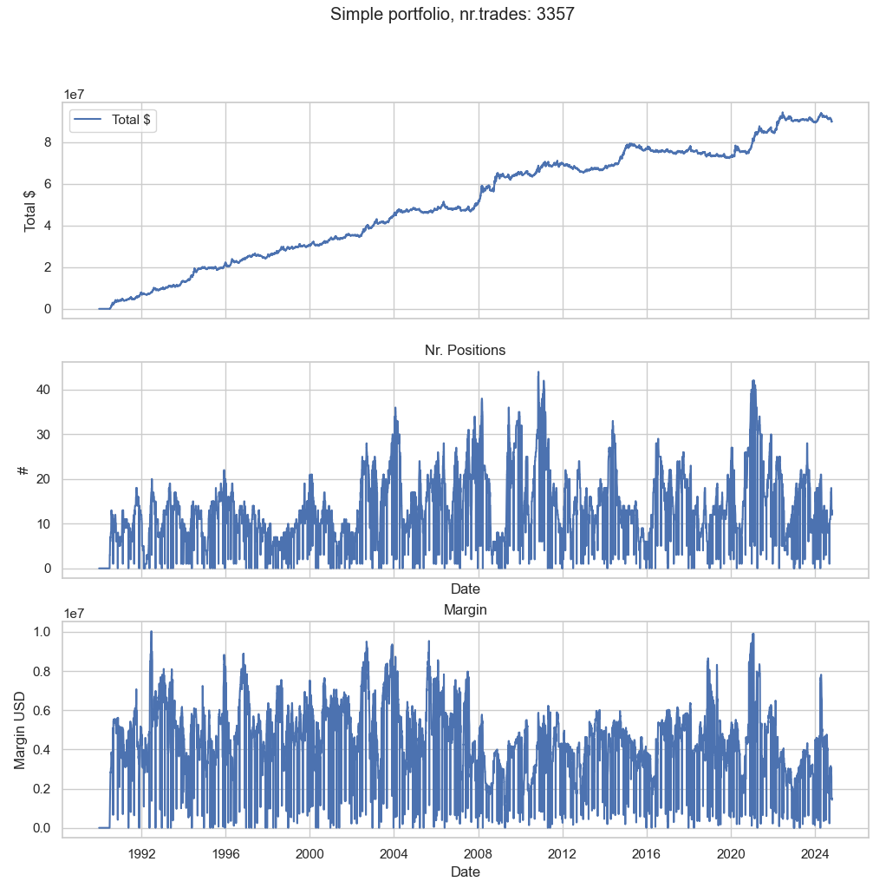

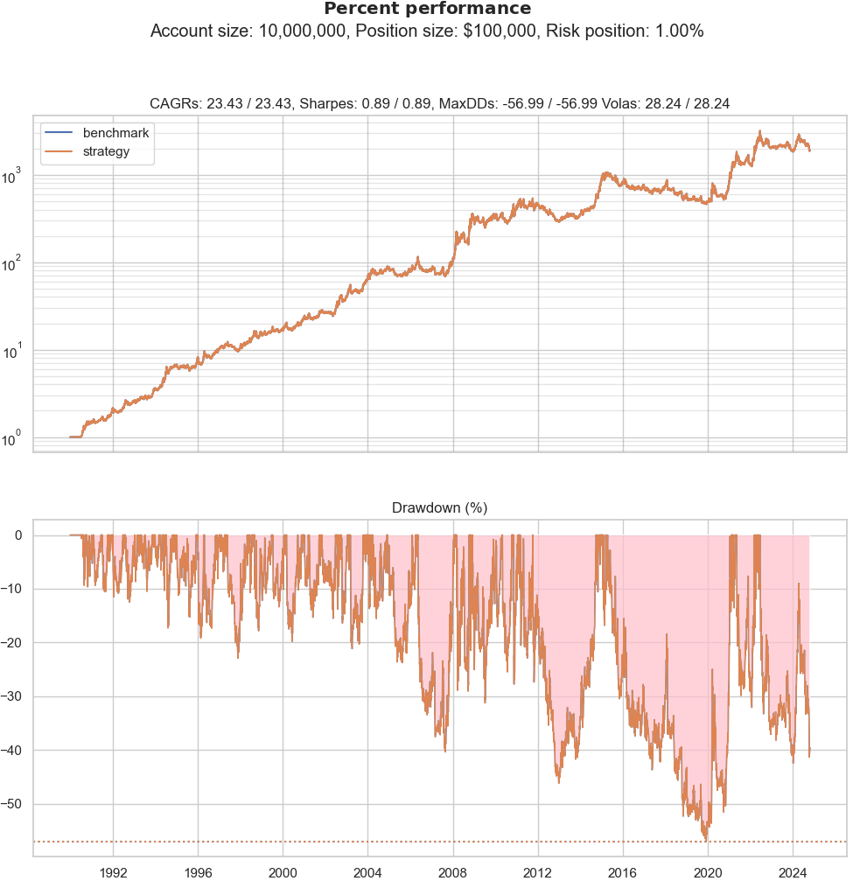

Affordable contracts

01.11.2024

Backtested only contracts in USD, EUR and GBP, no micro-contracts.

No limit price limit:

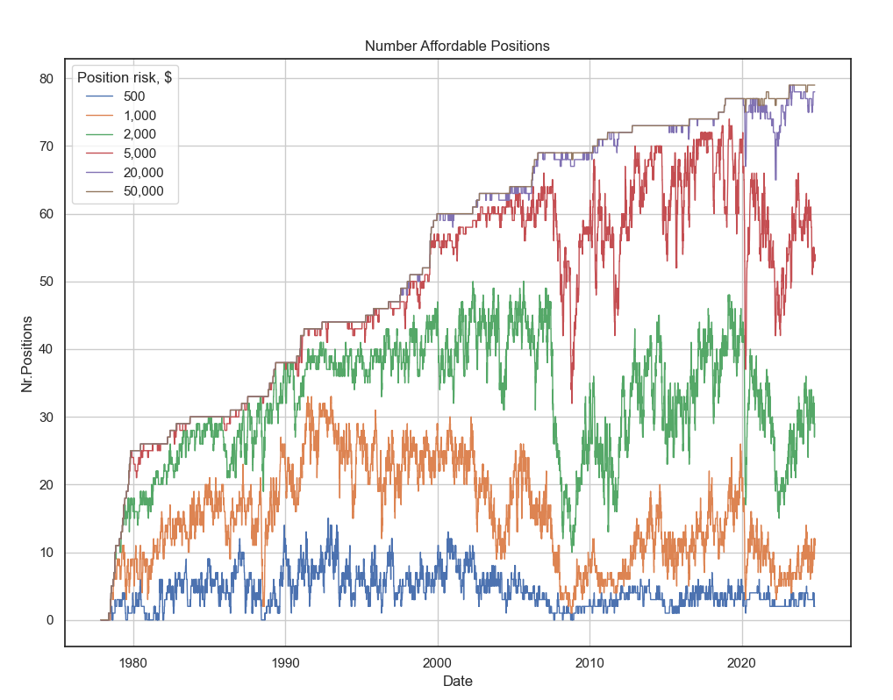

The same with the trading strategy:

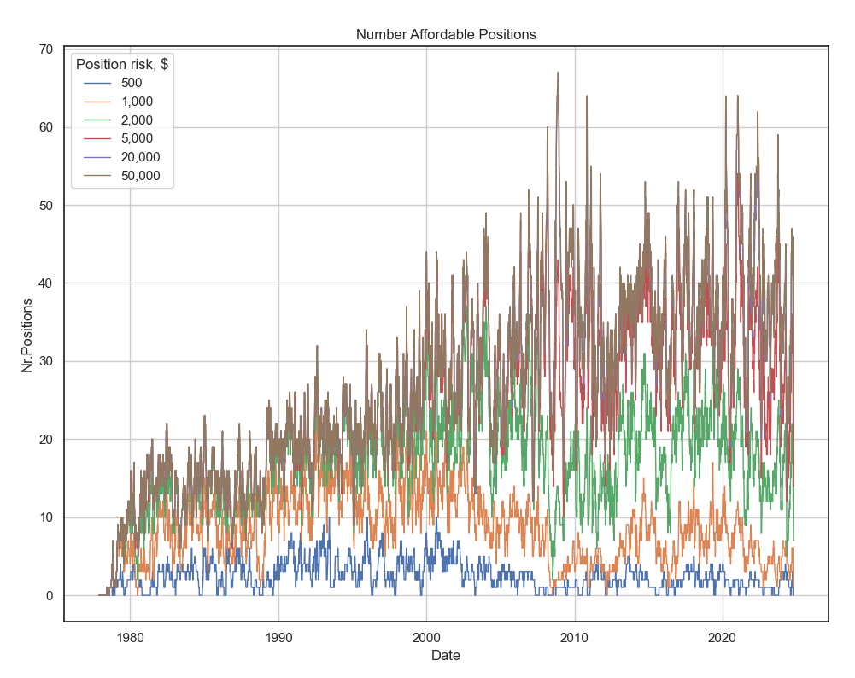

Only recent dates

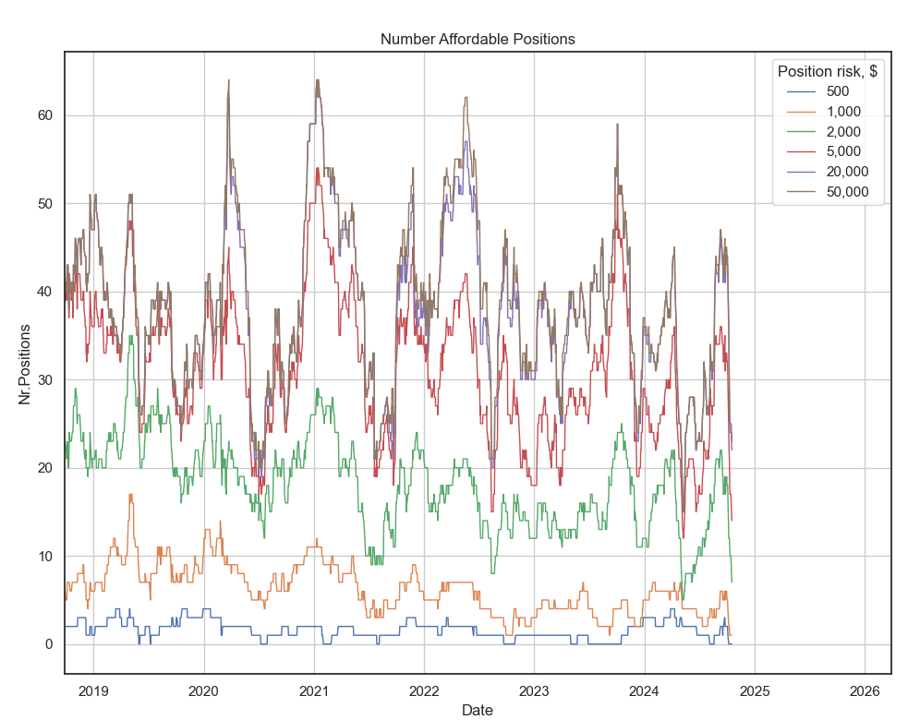

No trading strategy, with micro contracts

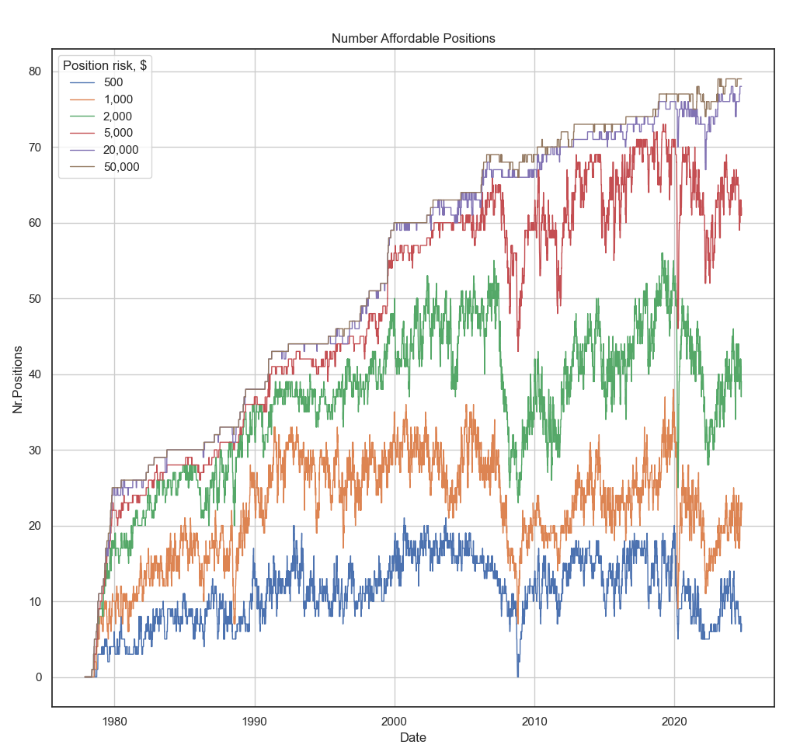

Backtests on 15.11.2024

Compare long-only portfolio with loose pants portfolio

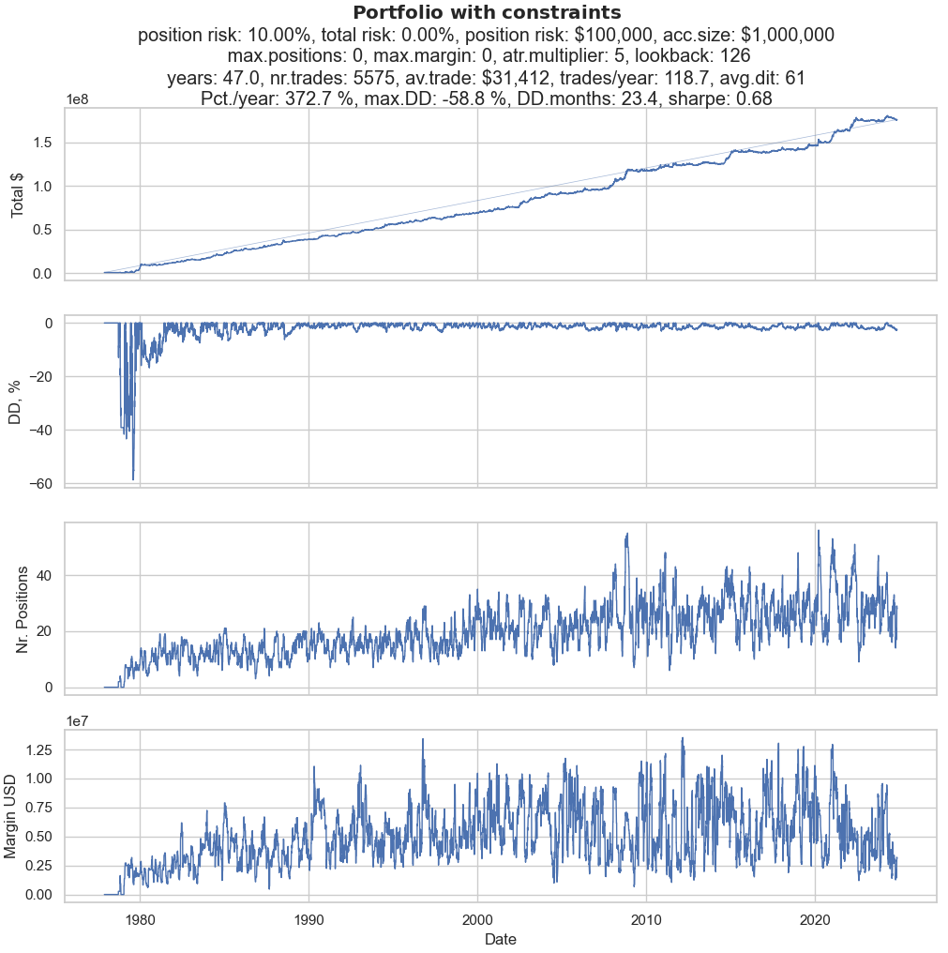

Buy&Hold long only?

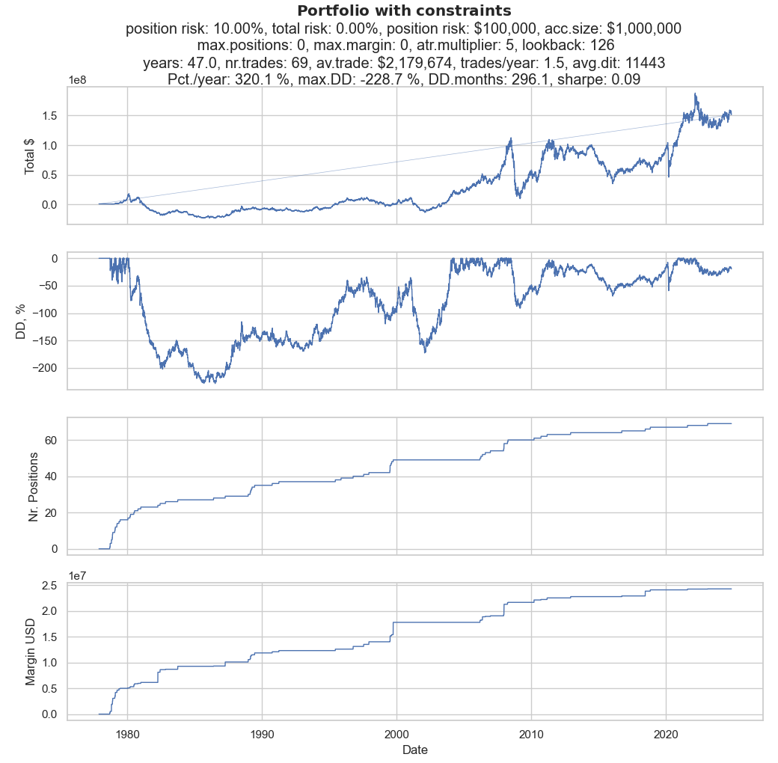

# Check sensitivity to lookback period

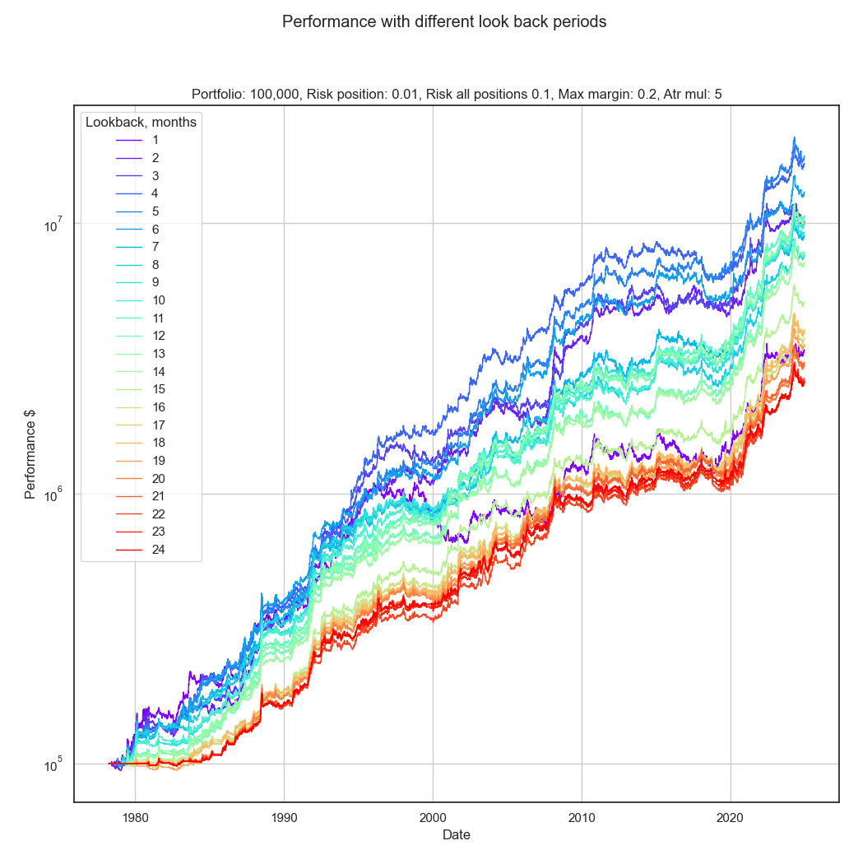

Up to 12 months only:

